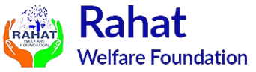

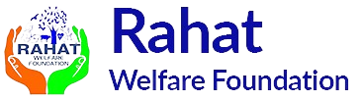

**Project RWF - Udaan**

**Okhla , Delhi NCR**

*FY 2024-25*

**Head Office** – 3A, 2nd Floor Jasola Village Near Aggarwal New Delhi-25

www.rahatwelfarefoundation.in

Submitted by

**Executive Summary**

|  |  |
| --- | --- |
| **Title of the Project** | Project RWF - Udaan |
| **Submitted to** | Sattva Consulting |
| **Duration of the Project** | 12 months |
| **Target Group** | Primery and middle schools students of okhla Delhi Private/ Government school. |
| **Location** | Okhla, South East Delhi |
| **Target Number of Students** | 2500 |
| **Target Number of Schools** | 10 |
| **12 A & 80 G Certificate** | AACTR2215GE20211 (12A),  AACTR2215GF20221 (80 G ) |
| **FCRA No** | N/A |
| **Trust Registration No** | 1783 |
| **Budget** | **3009500** |
| **Per Beneficiary Cost** | **1204** |

**Introduction**

**About Rahat Welfare Foundation (RWF):** Rahat Welfare Foundation (RWF) is a charitable trust established in Delhi on February 25th, 2010. Our primary objective is to promote universal education across India, with a particular emphasis on improving the living standards of women.

Our focus is on empowering women and girls, who are disproportionately affected by poverty and discrimination. They often face abuse, violations of their rights, and limited access to resources. By addressing these issues, we aim to create a more equitable society.

Initially, we relied on funds raised primarily from family and friends, which is common for many young organizations. This initial support played a crucial role in instilling a sense of volunteerism and dedication within our team. Over time, as our work gained recognition and support, we expanded our network and attracted funding from various sources, including corporate sponsors, government grants, and individual donors. This financial support has allowed us to scale up our programs and reach a larger number of beneficiaries.

One of our key initiatives is providing scholarships and educational support to underprivileged girls. We believe education is a powerful tool for empowerment and social change. Through our scholarship program, we aim to break the cycle of poverty and provide opportunities for girls to pursue their dreams and aspirations.

In addition to education, we focus on providing vocational training and skill development programs for women. By equipping women with marketable skills, we enhance their employability and economic independence. This, in turn, contributes to the overall development of their families and communities. Raising awareness about women's rights and advocating for gender equality is another crucial aspect of our work. We organize workshops, seminars, and awareness campaigns to educate both women and men about the importance of gender equality and the need to challenge societal norms and stereotypes.

We actively collaborate with other organizations and stakeholders to maximize our impact. By forming partnerships and alliances, we leverage resources and expertise to work towards common goals. This collaborative approach has allowed us to implement larger-scale projects and address systemic issues that hinder women's empowerment.

As we continue to grow and evolve, we remain committed to our mission of promoting education and improving the lives of women in India. We believe that by investing in women's empowerment, we can create a more inclusive and just society for all. Through our efforts, we strive to inspire and empower women to become agents of change in their own lives and communities.

**Geographical Reach**

Our footprint spans Uttarkhand, Uttar Pradesh, Delhi, Delhi NCR, where we've made significant strides in education and skill development.

**Core Thematic Areas:**

* Tech enabled foundational learning
* Skilling Development training with a focus on Digital Literacy and Livelihoods Options
* Women empowerment through digital inclusion, financial literacy and Gender Justice
* Health improvement program for merginaralized family for their quality life.

**Accolades and Recognition:**

Rahat Welfare Foundation is a credible trust accredited by esteemed institutions such as The verge (Certificate of excellence) for the year of 2023/24, Outstanding achiement award from Haryali central and rular development for the year of 2022/23, Certificate of honors by international life skills technology private limited for the year of 2022/23, Best Achiement Award / apprieacian From watan samachar for the year of 2021/22.

Apart from the above, Rahat Welfare Foundation has established close linkages with the communities residing in remote rural areas and urban slums over the past 14 years. This existing rapport provides a solid foundation for **community engagement** and support for the implementation of the skill / education development projects. With over **14 years of experience** working in the education, skill and livelihood sector RWF possesses valuable insights into the challenges faced by students, particularly those attending government schools in the region. This deep understanding of the educational landscape enables RWF to tailor interventions effectively to address specific needs and gaps in skill-training.

**Problem Statement**

The Indian Education System is one of the largest in the world with more than 1.5 million schools, 8.5 million teachers, and 250 million children from varied socioeconomic backgrounds. And yet, 32 million Indian children have never been to any school – devoid of an education, of a future.

Those children that continue to be schooled, grapple with syllabi and learning. Poor learning outcomes owing to poorly trained educators, teacher absenteeism, and poor infrastructure are only exacerbated by gendered discrimination, parental neglect, and lack of awareness.

This remarkable disregard for learning levels is most strikingly accounted for in the recent ASER indicating the severity of the problem and the urgency of remedial action. According to the report, barely 48.1% of children in class 5 in government schools can read a class 2 text. More than 57% of class 1 students are unable to recognize the alphabet. As a consequence of such neglect, India’s children continue to drop out of school at an alarming rate – 40% of them do not finish primary school.

The educational requisites of a largely footloose and impoverished population also remain markedly distinct – frequent in and out migrations often mean long absences from the classroom, a hostile familial environment, and the severity of income poverty also compound the already extant high drop-out rates and poor learning outcomes. Migration remains under-addressed in the extant state education policy with the result that migrant children remain the most educationally marginalized in the country.

Rahat Welfare Foundation primary survey has highlighted the low literacy rate as a significant challenge within the community. Additionally, there is a notable lack of STEM (Science, Technology, Engineering, and Mathematics) learning opportunities, which are crucial for the development of critical thinking and problem-solving skills. The educational deficiencies in Okhla, Delhi & NCR are not just a reflection of current systemic issues but are also rooted in long-standing generational and community-based gender issues.

In today's interconnected digital landscape, this unfortunately leads to school-age children lacking a crucial skill that could significantly enhance their prospects for higher education and employment opportunities. Only through interventions focused on infrastructural refurbishment in schools and the community, can the cycle of educational disadvantage be broken, paving the way for acquiring new age skills for the young boys and girls of Okhla Delhi & NCR.

**Project Demographic**

Okhla Delhi & NCR is a part of a sprawling Muslim ghetto in Southeastern Delhi. Situated on the right bank of the Yamuna, Okhla is surrounded by NFC and is a part of the densely populated neighbourhood in Delhi. The settlement itself remains one of the ten-odd ghettoes that make Okhla inhabited by precariously poor migrant families, itself a striking imagery of radical disparities and inequities.

Okhla remains one of the most impoverished settlements in the neighbourhood. Estimates of resident populations are difficult to come by since the settlement sees continuous and persistent in and out-migrations. A cursory estimate would indicate a population of approximately more than 25000 households. With a burgeoning population of migrant labourers from the states of Bihar, Bengal, Uttar Pradesh, and Assam, the settlement continues to sprawl and proliferate on the banks of the Yamuna and on the margins of Jamia Nagar colony. Home to a substantial number of rickshaw-pullers and a large majority of casual workers, the settlement also sees small, informal manufacturing units. The latter, however, remains minimal. Vulnerable to exploitation at the hands of contractors and suffering both, the lack of regular wage-employment and severely adverse working conditions, the community suffers despair and destitution and continues to eke out a living by intermittent work.

Rahat Welfare Foundation preliminary survey indicates a striking lack of adequate educational facilities in the settlement. The existing schools overrun their capacity given the proliferating settlements in the neighbourhood. The community also sees a significant proportion of school dropouts given frequent immigration and emigration, income deprivation, and cultivated diffidence among the residents. Lacking provisions for bridge learning and flexible intakes, the established schema of schooling also thwarts continued education amongst migrant communities. Children from such communities’ often manifest prolonged periods of absence, have to forgo examinations, and thus remain particularly vulnerable to dropping out. Malnutrition and high rates of morbidity also compound poor performance and high rates of drop-outs. Learning outcomes remain dismal given intermittent school attendance and conditions of learning and living that most significantly impact the possibilities of schooling and learning.

**Why Rahat Welfare Foundation?**

Rahat Welfare Foundation (RWF) extensive experience, community engagement, successful track record, and commitment to quality education make it well-positioned to implement STEM lab projects effectively in the targeted areas of Okhla (Specially Okhla Vihar), ultimately benefitting students and contributing to their academic success.

**Other Compelling Reasons which make Rahat Welfare Foundation Trust the best Non-Profit to implement the said project:**

1. **Community Engagement:** Rahat Welfare Foundation has established close linkages with the communities residing in remote rural areas of Uttrakhand, Uttar Pradesh and Delhi NCR India over the past 14 years. This existing rapport provides a solid foundation for community engagement and support for the implementation of the STEM lab projects along with capacity building of teachers in Government Schools of the said locations. The trust and relationships built with local communities, government agencies and Government schools can facilitate smoother project execution and sustainability.
2. **Experience and Understanding:** With over 14 years of experience working in the education, Skill & Livelihood sector, Rahat Welfare Foundation possesses valuable insights into the challenges students face, particularly those attending government schools in the region. This deep understanding of the educational landscape enables Rahat Welfare Foundation to tailor interventions effectively to address specific needs and gaps in STEM education.
3. **Track Record of Success:** For the last decade Rahat Welfare Foundation has been offering remedial classes of government school students of Uttarakhand, Uttar Pradesh & Delhi NCR for classes Nursery to XII Standard (Focus on Dropout students to stream their learning capacity) . These students have achieved 2X better results than their fellow classmates and many have cleared the board examination with distinction. This has been a boon for rural/Semi Urban students whose education is impacted by these significant educational deficiencies. Through this initiative, Rahat Welfare Foundation provides supplementary assistance to school students who miss out on acquiring knowledge due to unqualified teachers in government schools. Rahat Welfare Foundation has provided quality education impacted learning level of over 2000 students in the rural/semi urban remote areas of Uttarakhand, Uttar Pradesh, Delhi & NCR and helped them get higher quality education.
4. **Commitment to Quality Education:** Rahat Welfare Foundation's longstanding commitment to improving educational quality aligns well with the objectives of the STEM lab projects. Students in Rahat Welfare Foundation’s Learning Centres in Delhi are provided with Tabs, computers and tools for creating conceptual clarity in maths and science from class Nursery to XII Standard students. Thus, more than one decades Rahat Welfare Foundation has provided quality education to over 2000 students from low-income communities.
5. **Potential for Impact:** The implementation of STEM lab projects has the potential to significantly enhance STEM education outcomes for students in targeted semi urban areas. By leveraging its expertise, community relationships, and proven track record, Rahat Welfare Foundation can maximize the impact of these projects, empowering students with essential STEM skills and fostering a culture of learning and academic excellence in the region.

**P****roject Location**

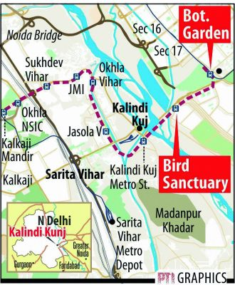Okhla - Okhla Vihar Village is comes under southeast delhi. Okhla Vihar is a new settlement in Okhla, in the district of South East Delhi, India. It consists of many lanes and many sub-lanes. Over 80% of the area of Okhla Vihar is covered with 5-story apartments. most of the residents of this area came from the surrounding states such as uttar Pradesh, Bihar west Bengal Orissa and Haryana and Rajasthan

Government of India's think tank, identified this place one of the most under privilege and under develop area.

**Need Assessment**

Rahat Welfare Foundation team recently conducted a need assessment in below number of the private / government school to understand the condition of learning ability of female students towards STEM subjects. A need assessment was conducted to identify the challenges faced by Primery and middle school students in Government/Private Schools of this Okhla vihar area.

**Survey Sample**

|  |  |
| --- | --- |
| **Total Schools** | 10 |
| **Total Target Students** | 2500 |

**Survey Report:**

1. **Objective of the Survey:** To understand the communities’/students needs and requirements for improving educational impact and facilitate computer literacy for an overall upliftment of the community. Our objective was also to identify the most appropriate and potential school and required skills where Rahat Welfare Foundation Trust could provide computer literacy to underserved students among the selected Okhla vihar thereby including them in the digital world.

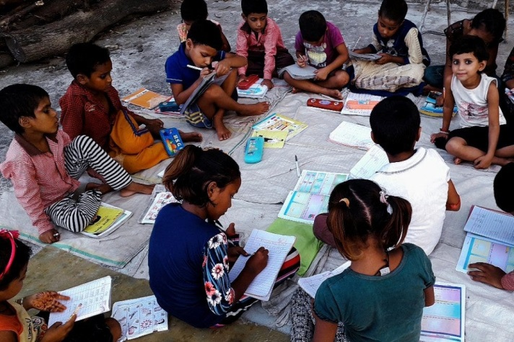

1. **Survey Sample-** The survey was conducted among community and teachers of schools (Government / Private) to know the need/requirement of STEM learning education for the students to provide quality education. After need base survey we came to know that there is desperately need of quality education through STEM learning process in each and every targeted/identify schools
2. **Observations-**

* **Education:** Most of the Parents, from this area lack formal education. Many children either did not attend school or received poor schooling due to socio-economic and infrastructural limitations , resulting in reduced access to high-quality education. The needs assessment revealed that the educational requirements of the students was not met.

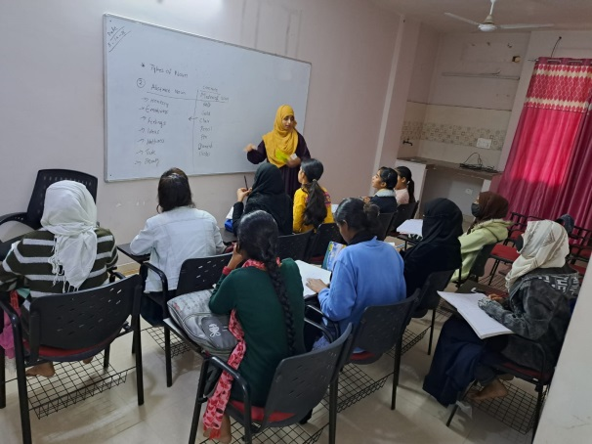

* **Infrastructure in schools-** Following discussions with community members, and school officials, it was observed that the schools in the villages required improvement in quite a few infrastructural. Some school’s teachers reported to Provide continue support for technical learning such as STEM toys for their primary and middle schools students.
* **Student-teacher ratio-** Some schools reported shortage of teachers in most of the private schools. This led to poor quality of education as many classes were not held due to the lack of teachers. As a result, the students lost interest in education Most teachers lacked teaching aids to teach subjects like science and Maths (STEM subjects).

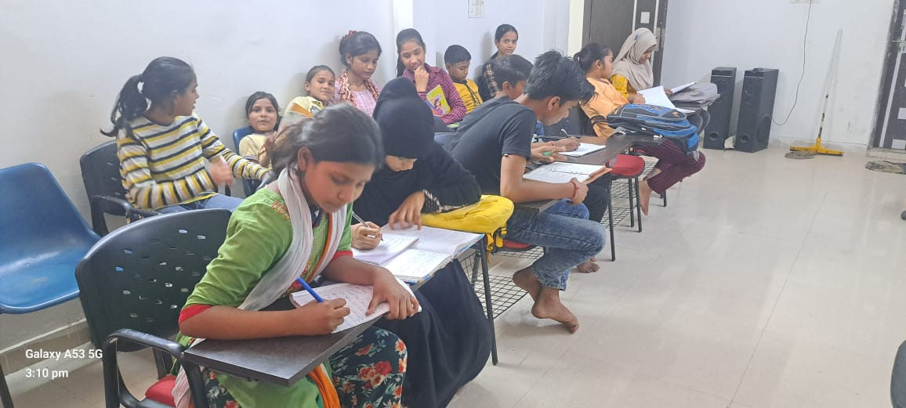

* **Lack of resources and equipment-** Some private schools in the Okhla – Okhla Vihar had a room for a computer lab but due to lack of equipment/ financial constant, the labs were not used properly. Some schools did not have labs at all, and the teachers appointed to teach the subject engaged in other school activities due to lack of resources. None of the schools had any provision of STEM labs within their premises which also hindered students’ interest or awareness towards the concepts of STEM subjects.
* **Gendered socialization-** The community had a clear gendered approach towards education, employment and living conditions. Girls from the community did not pursue higher education, sometimes beyond primary school due to restrictions on mobility and transportation. Eventually, women were home-bound and did not pursue employment options and continued to live within the village periphery and contribute to family’s livelihood through daily wages work activity.

1. **Community Feedback:** The field visit emphasized the urgent need for comprehensive interventions to address the Okhla – Okhla Vihar needs for improved educational facilities for school students through refurbishment and accessibility of infrastructural facilities which would ultimately support to bridge the educational and digital literacy gap. School officials emphasized on the need for provision of better teaching and learning environment in the schools. Students are enthusiastic about computer science and STEM fields.

* Limited access to smartphones and computers at home hinder their digital skilling and accessing STEM related learning material.
* Lack of availability of computers at school underscores the need for improved technology access.
* There is a clear demand for dedicated computer labs and STEM labs for girls in close proximity to their villages. The girls aren’t sent to the cities for up- skilling like their male siblings and other male children, so are left out.
* The girls have aspirations for New Age Careers but have no clear understanding of how they could attain it. They are in need of guidance and career counselling.
* The girl/boys students need exposure to STEM concepts and equipment to gain conceptual clarity and learn by doing. This would create a life-long interest in these subjects and create a need in their mind to pursue them as career options.

Due to the unavailability of resources, the children get discouraged from pursuing studies in Science, Technology, Engineering, and Mathematics (STEM), which help them to develop a logical and analytical bent of mind.

**Project Implementation**

We propose the establishment of STEM Labs in 10 private/government schools along with focused teacher training and capacity building in said private/government schools located in Okhla – Okhla Vihar. These STEM Labs will provide a conducive learning environment for students to enhance their STEM skills and understanding. The project aims to benefit 2500 students by providing them with hands-on learning experiences and fostering a love for STEM subjects.

1. **Project Objectives:**

* To improve students' proficiency in STEM subjects and problem-solving abilities.
* To strengthen teachers’ ability to cater to school students through focused training programs.
* To create an engaging and interactive learning environment for students.
* To enhance students' conceptual understanding of STEM concepts.
* To promote critical thinking and analytical skills among students.
* To increase students' interest and enthusiasm for STEM subjects.

1. **Project Activities**

|  |  |
| --- | --- |
| **Component** | **Detail** |
| **Setting Up STEM Labs** | * Procuring necessary equipment, such as models, manipulatives, and educational resources. * Establishing a dedicated space within each school for the STEM Lab. * Ensuring proper organization and arrangement of materials for easy access and utilization. |
| **Curriculum Development** | * Designing a comprehensive and age-appropriate curriculum for each grade level. * Developing lesson plans and instructional materials aligned with the curriculum. * Incorporating hands-on activities, experiments, and real-life applications of STEM concepts |
| **Teacher Training** | * Conducting training workshops for teachers to familiarize them with the STEM Lab resources and teaching methodologies. * Providing guidance on effectively implementing the curriculum and engaging students in interactive learning experiences. * Professional development workshops for teachers to enhance their STEM teaching skills. * Implementation of hands-on, project-based learning activities. * Collaboration with experts and institutions specializing in STEM education. * Access to resources and materials necessary for effective STEM instruction. * Encouraging a culture of innovation and creativity in the classroom. * Support for teachers in developing and implementing STEM lesson plans. * Encouraging collaboration and knowledge-sharing among teachers through regular meetings and professional development sessions |
| **Student Engagement** | * Organizing competitions, quizzes, and interactive sessions to foster healthy competition and student participation. * Arranging guest lectures by STEM experts and professionals to inspire students and showcase the practical applications of STEM subjects. * Encouraging students to explore STEM beyond the classroom through projects, research, and problem-solving challenges. |
| **Implementation and Monitoring** | * Rolling out the STEM lab program in the selected surveyed schools, ensuring smooth integration with the existing curriculum. * Monitor the progress of students and teachers regularly through assessments, surveys, and feedback sessions. * Provide ongoing support and guidance to teachers to address any challenges faced during the implementation phase. |
| **Community Engagement** | * Involve parents, community members, and local stakeholders in the initiative to garner support and create awareness about the importance of STEM education. * Organize open houses to showcase student projects and achievements, fostering a culture of STEM appreciation within the community. |
| **Integration of Real-Life Applications** | * Integrating real-life applications and problem-solving tasks into the curriculum to demonstrate the practical relevance of various concepts. * Encouraging students to apply their STEM skills in everyday scenarios such as budgeting, measuring, and calculating discounts, thereby enhancing their understanding and retention of the concepts. |
| **Evaluation and Scaling** | * Evaluating the impact of the STEM lab program through quantitative and qualitative measures such as academic performance, student engagement, and teacher satisfaction. * Using the findings to make necessary adjustments and improvements to the program. * Considering scaling up the initiative to more schools and regions based on the success and learnings from the initial phase. |
| **Sustainability** | * Developing a sustainability plan to ensure the long-term viability of the STEM labs, including securing funding, training new teachers, and updating resources regularly. * Fostering partnerships with government agencies and corporate sponsors to support ongoing operations and expansion efforts. |

1. **Project Timeline**

Proposed timeline for opening STEM labs in 10 Private & government schools of Okhla – Okhla Vihar area of South East Delhi over a 12-month project period:

|  |  |
| --- | --- |
| **Monthly Timeline – 12 Months Period** | **Components** |
| **Month 1**  **Preparation, Planning, and Infrastructure setup** | * Procure and install necessary equipment and resources. * Establish STEM labs in each of the 10 selected schools- including refurbishment of existing rooms in selected schools * Baseline assessment of the students - pretest of the students for their class-appropriate STEM ability to be conducted * Evaluation shared with the school principals. * Recruit project coordinator |
| **Month 2**  **Training, Orientation, and Curriculum Implementation** | * Curriculum finalization * Orientation of project staff including teachers * Conduct initial training sessions for teachers on using the STEM lab resources effectively. * Roll out the STEM lab program in all 10 schools. * Implement the developed curriculum, incorporating hands-on activities and real-life applications. |
| **Month 3-4**  **Capacity building, monitoring and evaluation** | * Monitor and assess student progress and teacher performance regularly. * Conduct quarterly review and risk-mitigation meeting with project implementation team and head office in two locations * Organize meetings with teachers to share best practices and address challenges |
| **Month 5-8**  **Continued implementation of the program, monitoring & evaluation, regular repair and maintenance** | * Provide ongoing training and support for teachers on pedagogical methods and utilizing STEM lab resources. * Organizing Intra school and Inter School competition or exhibition to display students’ learnings * Monitor and assess student progress and teacher performance regularly. * Conduct quarterly review and risk-mitigation meeting with project implementation team and head office in two locations |
| **Month 9-10: Community Engagement and Awareness** | * Organize annual Exhibitions for parents and community leaders for awareness and display of the program through students’ learnings * Collaborate with local stakeholders and community organizations to garner support for the initiative. * Collect feedback from parents, students, and teachers to inform program improvements. * Conduct quarterly review and risk-mitigation meeting with project implementation team and head office in two locations |
| **Month 11-12: Evaluation, Scaling, and Sustainability** | * Evaluate the impact of the STEM lab program through quantitative and qualitative measures. * Analyze the findings and make necessary adjustments to the program. * Conduct final review and feedback meeting with project implementation team and head office in two locations * Develop a sustainability plan for the continued operation of these labs beyond the project period. * Prepare a comprehensive report documenting the project outcomes, lessons learned, and recommendations for future implementation. * Explore opportunities for scaling up the initiative to more schools or regions based on the success of the pilot project. |

1. **Risk & Mitigation**

|  |  |
| --- | --- |
| **Component** | **Details** |
| **Infrastructure Delays** | Risk: Delay in procuring equipment or setting up infrastructure could hinder the project timeline.  Mitigation: Starting the procurement process early, maintain open communication with suppliers, and have backup plans in place. Considering leasing equipment temporarily if necessary. |
| **Teacher Resistance or Turnover** | Risk: Resistance from teachers or high turnover rates could affect the successful implementation of the STEM lab program.  Mitigation: Providing thorough training and support for teachers from the outset. Addressing any concerns promptly and involve teachers in the planning process to foster ownership and buy-in. |
| **Resistance from female students towards STEM** | Risk: Female students in India exhibit a 20% lower likelihood of opting for STEM in comparison to male students.  Mitigation: To address this, effective mentorship, and role modeling and creating inclusive learning environments offering career guidance is key. |
| **Natural Disasters or Unforeseen Events** | Risk: Natural disasters, political unrest, or other unforeseen events could disrupt project activities.  Mitigation: Developing contingency plans and emergency protocols to address potential disruptions. Monitoring local conditions and stay informed about potential risks. Establishing communication channels for quick response and coordination in case of emergencies. |

Project will be implemented in a phased manner dividing into three phases:

**Set- up, Scale up and Sustain**

**Phase 3**

**Phase 2**

**Phase 1**

* Creating linkages for furthering tech careers
* Hand holding teachers in incorporation and integration of their Learnings with their lesson plans
* Teacher and Student Evaluation
* Project Evaluation ( Qualitative & Quantitative)
* Annual Report Generation
* Student and Teacher Training continues
* Preparing class timetables and running the classes for computer , STEM and Soft Skills
* Career guidance workshops, Gender sensitization workshops and soft skills etc
* STEM Mela at the Block level for parent and community engagement
* Identification of the villages and schools.
* Selection & Recruitment of the Resource Persons for training
* Identifying the vendors
* Purchase of required items
* Preparing course curriculum
* STEM exhibitions in Schools
* SET up STEM Lab in 10 schools
* Capacity development of students and teachers

*A Detailed curriculum will be shared for each subject after in principal agreement to the said proposal is received.*

**Intervention with donors, teachers and school authorities**

* In order to implement all above activities and programs with children, teachers and entire school system should be aware and trained enough to conduct the same with children.
* Review of every week and ever month activity would be discussed with teachers. So that, sufficient care and necessary steps could be taken by teachers for the growth of students
* Updates in the form of monthly reports will be shared and presented before the school team and the donor agency
* Quarterly visits will be planned for the Donor agency or as per the requirement

**Intervention with community members and Other Stakeholders**

Awareness sessions through the STEM melas would be conducted twice during the year in a village. Such sessions would be conducted regarding growth aspects that are important for their children.

1. **Expected Outcomes:**

* Improved teaching abilities amongst teachers in 10 private & government schools
* Improved proficiency and problem-solving skills in STEM subjects among 2500 students.
* Increased interest and enthusiasm for STEM.
* Enhanced conceptual understanding and critical thinking abilities.
* Higher academic performance in STEM subjects
* Long-term impact on students' career choices and opportunities.
* Reduction in out-migration
* Decreased resistance from female students towards pursuing STEM subjects

1. **Sustainability Plan**

To ensure the sustainability of the labs, we propose the following strategies:

* Collaboration with local educational authorities and stakeholders for continued support and funding.
* Integration of the STEM Lab curriculum into the regular school curriculum.
* Training of additional teachers to expand the reach of the STEM Labs.
* Regular monitoring and evaluation to assess the effectiveness of the STEM Labs and make necessary improvements.

**Budget**

*As Annexure ‘A’*